**Why do we need plugins?**

* They can improve our work efficiency.
* They help reduce repetitive tasks, so we don't have to do the same work over and over again.
* They minimize programmer mistakes.

**Note:**

* First, never download plugins that upload your code, such as AI plugins like GitHub Copilot or similar ones.
* Second, plugins depend on what you need, so there are no strict rules.  
  Just pick the plugins you need.

**How to install plugins?**

Click Settings → Plugins → Marketplace

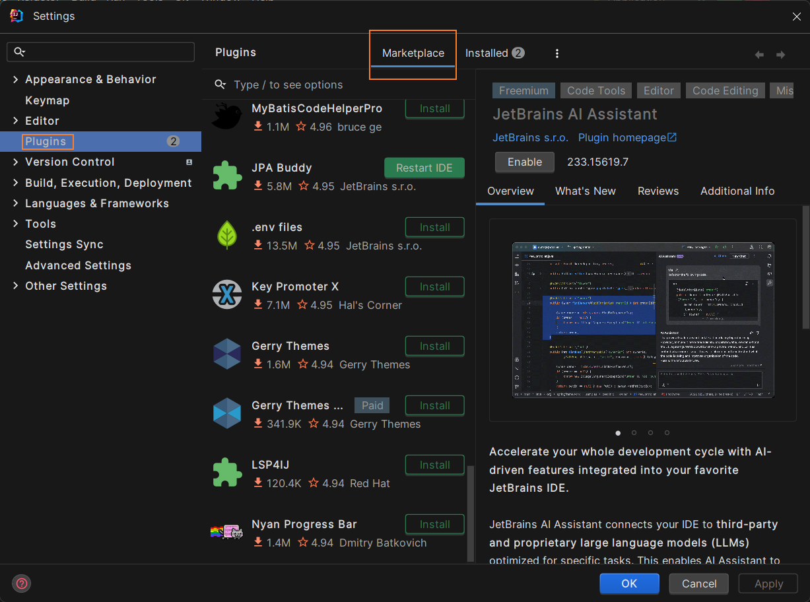

***About IDE appearance***

**Atom Material File Icons: Comfortable Icon plugin**



**VSCode Theme: Provides Visual Studio Code / VSCode Editor Color Scheme for Jetbrains IDEs**

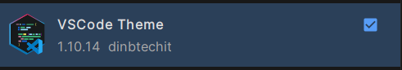

**VSCode keymap: VSCode keymap replaces Intellij IDEA keymap**



***About development Plugins***

**MybatisX: Provide easy way to jump or back when we use mybatis**



**Maven helper: Easy way for analyzing and excluding conflicting dependencies**



**Grep Console: Change colors of matching text.**

